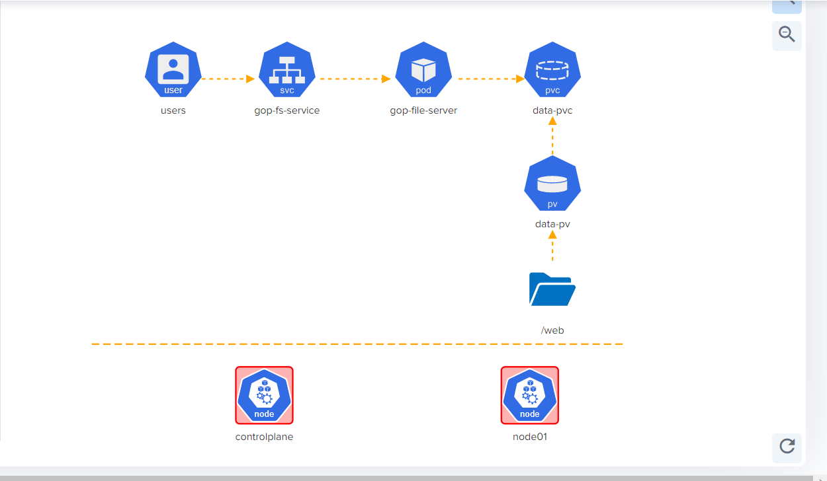

Problem 1

* New Service, name: 'gop-fs-service'
* Service name: gop-fs-service, port: '8080'
* Service name: gop-fs-service, targetPort: '8080'

Problem 2

* Create a pod for fileserver, name: 'gop-fileserver'
* pod: gop-fileserver image: 'kodekloud/fileserver'
* pod: gop-fileserver mountPath: '/web'
* pod: gop-fileserver volumeMount name: 'data-store'
* pod: gop-fileserver persistent volume name: data-store
* pod: gop-fileserver persistent volume claim used: 'data-pvc'

Problem 3

* Create new PersistentVolumeClaim = 'data-pvc'
* PersistentVolume = 'data-pvc', accessModes = 'ReadWriteMany'
* PersistentVolume = 'data-pvc', storage request = '1Gi'
* PersistentVolume = 'data-pvc', volumeName = 'data-pv'

<https://github.com/Sofoniasm/Kubernetes-challenge-/blob/main/pvc.txt>

* Create new PersistentVolume = 'data-pv'
* PersistentVolume = data-pv, accessModes = 'ReadWriteMany'
* PersistentVolume = data-pv, hostPath = '/web'
* PersistentVolume = data-pv, storage = '1Gi'

<https://github.com/Sofoniasm/Kubernetes-challenge-/blob/main/pv.txt>